**AntiWave Lane Checklist July 19, 2018**

**Rev. 4**

The below information must be received on each and every order.

We prefer that this information resides directly on the PO.

We cannot receive an order unless this information is specified.

Additional details about all these items are located in the following pages.

**AntiWave Lane Checklist – Required Information on Purchase Orders**

1. Confirm length, Hook to hook length is ­­­­­­­­­­­­________ Inches
2. Lead in length is 15 Feet on either end of the lane, or choose 5M. The Lead in color is _________.
3. Backstroke Markers are at 15 Meters from each end. Markers are ______ color. Or Indicate No Markers.
4. Lane colors are _____________ solid or alternating at approximately every 3 feet. Markers are ______ color.
5. Supertensioner is _______ color, the same color as lead in, or different color from lead in.
6. Lanes connecting through gutters
7. Lanes with disconnects require further details, refer to
8. Water Polo Lanes have their own instruction documents, refer to Water Polo Course Overview
9. FINA and NCAA outline of markers, colors on last page of this document
10. **Length**

**🡪Hook to hook Length is ­­­­­­­­­­­­________ Inches**

Please confirm the length of your pool by measuring the inches of the pool.

It is not uncommon for pools to be 1-4 inches variation. Especially older pools.

This will be critical to give you the proper fitting lanes.



*\*Anything other than these lengths is considered Custom because it deviates from our standard norms. Custom lanes will require customer sign-off.*

1. **Lead In or “Ends”**

**🡪Lead in length is 15 Feet on either end of the lane.**

AntiWave has always built lanes with 15 Feet Lead Ins. A customer can request 5 Meter Lead Ins at no additional charge since this is what FINA has for their standard.

Lead in is on either end of the lane. Both ends of the lane have a Lead in.

Customers typically choose the color they want for the lead in although FINA states these should be Red.

The Last Page has the NCAA and FINA rules for lead in length as these vary.

The Supertensioner is included in the Lead In measurement. The Supertensioner comes standard on all 60 Foot, 75 Foot, 25 Meter and 50 Meter Lanes and can be added to any custom lanes.

The Supertensioner typically matches whatever color the customer chooses for the Lead in.

In our lanes there is a Supertensioner on one end and a Hook on the other.

The Hook is part of the Lead In measurement on other side.



1. **Markers**

**🡪Backstroke Markers are at 15 Meters from each end.**

Backstroke markers are added to the majority of lanes. The backstroke marker marks the 15M mark from each end.  Swimmers are only allowed to stay under water for 15M or less from each wall and this indicates whether they are within the rules and regulations.  Swimmers are disqualified if they swim underwater past the 15M mark.

Backstroke markers are in a different color other than what is used in the course and can be selected by customer.

NCAA and FINA both specify 15M. Our Standard Markers are as follows.



1. **Colors**

**🡪Colors are _____________ solid or alternating at approximately every 3 feet.**

When we alternate colors we alternate them *approximately* every 3 feet. This is not exact due to the measurements of our discs as well as the pattern layout you are looking for.

For example, depending on the pattern you request, the colors may be 2.85 feet up to 3.5 feet.

FINA specifies certain lanes numbers in a course should be certain color. FINA Rules next page.

*\*Anything other than the standard approximate 3 feet is a Custom request. Custom lanes will require customer sign-off.*

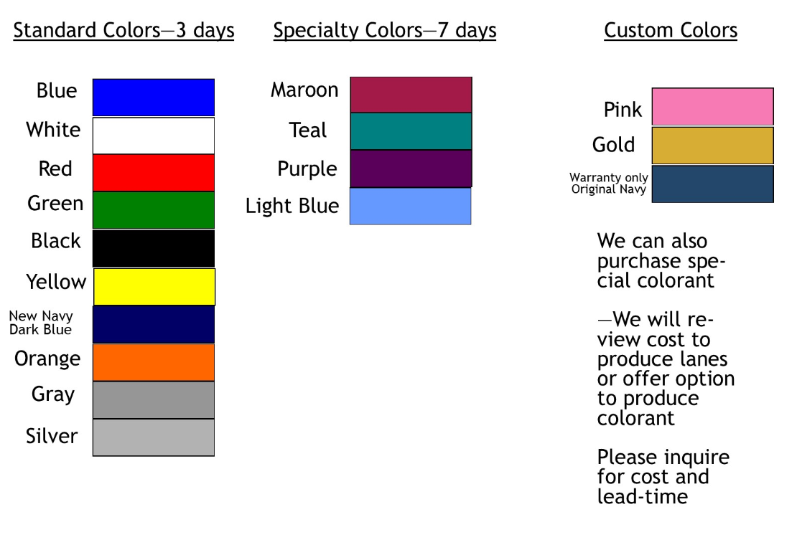

1. **Supertensioner**

**🡪Supertensioner is _______ color, the same color as lead in, or different color from lead in.**

The Supertensioner comes standard on all 60 Foot, 75 Foot, 25 Meter and 50 Meter Lanes.

One end has the Supertensioner

Our website has more information on the Supertensioner.

1. **Lanes connecting through gutters**

For lanes connecting through gutters we offer extensions hooks or overflow lane anchors.

Please provide a measurement schematic so that we can provide correct length lanes.

1. **Lanes with disconnects (for short and long courses)**

Require further conversation and review and customer sign-off.

Customer must explain details around short and long course and expectations for both long and short colors and markers. Some important questions:

1. Is customer expecting Leads Ins and Markers on both the short and long course? We recommend different colors for the markers so that they can differentiate.
2. If customer has extension sections confirm if they are in the center of the lane or on one end?
3. Water Polo Course Lanes have their own instruction document, refer to that document separately.
4. NCAA and FINA rules around Lead Ins, Markers and Colors.

NCAA – 15 Foot Lead In, 15 Meter Marker

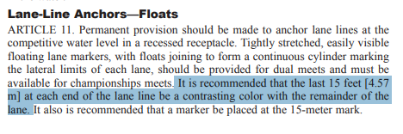

FINA – 5M Lead In, 15 Meter Marker

