**Water Polo Goal Replacement Flotation Pads October 31, 2019**

**Rev. 4**

Overview

Replacement Flotation Pads are developed and designed by AntiWave International (Australia) for use in AntiWave Goals. These pads are manufactured in China and shipped from AntiWave China.

Contents

* History
* New Pads
* Installing the Foam
* Part Numbers and Dimensions

History

Previously the Pads were 4 piece replacements (larger rear pieces and smaller front pieces). DISCONTINUED 2017.

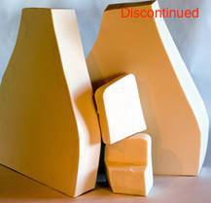

New Pads

The Pads are now 2 pieces with 1 piece foam each per side. The shape of the foam is longer and reaches into the area where the previous second piece foam existed.

The Flotation Foam pieces DO NOT fill the entire cavity. Replacement foam is installed between the Flotation Foam holders (marked A & B below).

The weight in the rear counterbalances the weight of the Front Frame, and the water filled rear cavity acts like shock absorber, to minimize goal bouncing on the water turbulence, which also reduces the dancing effect to the goal from direct shots to the frame.

The Goal floats stable and well on the water.

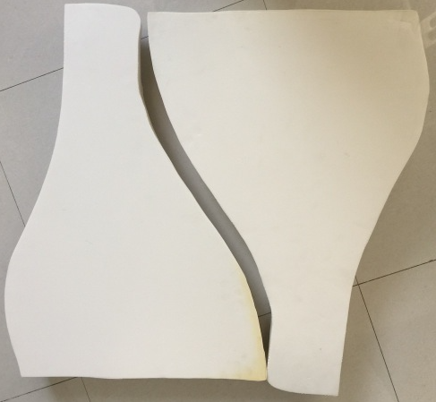 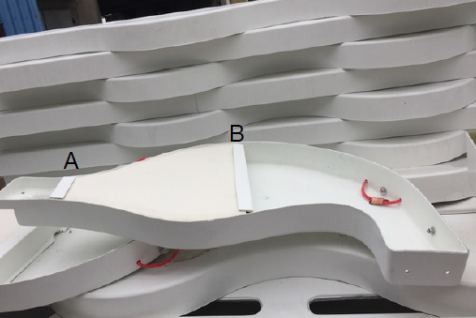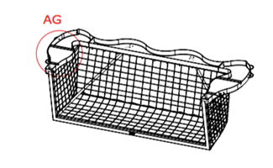

To Install the Foam:

1. Remove the existing EVA Foam Flotation Foams from the Fibreglass Cavity.

2. Remove any remaining Sikaflex adhesive from surface inside the cavity where the

previous Foam Float was positioned.

3. Use marine grade Sikaflex or local equivalent, to secure the foams to the inside of

the cavity.

4. Allow for the Sikaflex to set prior to installing the Goal in the water.

Part Numbers and DImensions

**AW0573 Flotation Pads/FlipFloat/Club**

Product Dimensions: 700 x 490 x 80 mm (27.5 x 19.3 x 3.15 inches)

Shipping Dimensions: 840 X 750 X 100 mm (33 x 30 x 4 inches)

1.6 kg or 3.5 lbs

**AW0572 Flotation Pads Odyssey**

Product Dimensions: 700 x 490 x 90 mm (27.5 x 19.3 x 3.5 inches)

Shipping Dimensions: 840 X 750 X 100 mm (33 x 30 x 4 inches)

1.8 kg or 4 lbs

**AWE499 Flotation Pads/Splashball Junior Flippa FloatFlip**

Product Dimensions: 500 x 450 x 80 mm (19.7 x 17.7 x 3.15 inches)

Shipping Dimensions: 810 X 540 X 100 mm (32 x 22 x 4 inches)

1.3 kg or 2.9 lbs