**Water Polo Goal Replacement Flotation Pads July 11, 2018**

**Rev. 3**

Replacement Flotation Pads are developed and designed by AntiWave International (Australia) for use in AntiWave Goals. These pads are manufactured in China and shipped from AntiWave China.

History

Previously the Pads were 4 piece replacements (larger rear pieces and smaller front pieces). DISCONTINUED 2017.

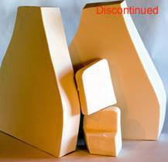

New Pads

The Pads are now 2 pieces with 1 piece foam each per side.

The shape of the foam is longer and reaches into the area where the previous second piece foam existed.

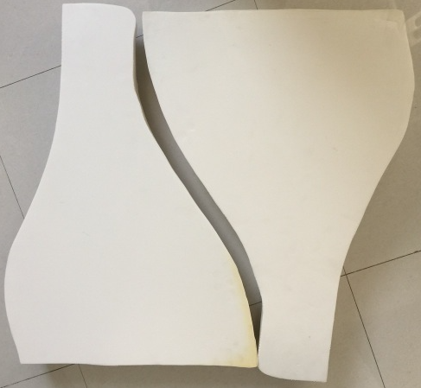 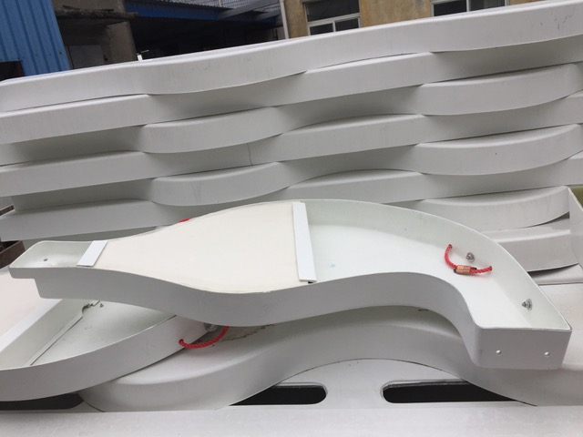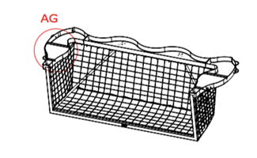

The weight in the rear counterbalances the weight of the Front Frame, and the water filled rear cavity acts like

shock absorber, to minimize goal bouncing on the water turbulence, and to minimize the dancing effect to the goal from direct shots to the frame.

The Goal floats stable and well on the water.

For Installing the Foam:

Use marine grade Sikaflex or local equivalent, to secure the foams to the Fibreglass.

Part Number

**AW0573 Flotation Pads/FlipFloat/Club**

Product Dimensions: 700 x 490 x 80 MM THICK

Shipping Dimensions: 840 X 750 X 100mm, 1.6 kg or 3.5 lbs

**AW0572 Flotation Pads Odyssey**

Product Dimensions: 700 x 490 x 90 MM THICK

Shipping Dimensions: 840 X 750 X 100mm, 1.8 kg or 4 lbs

**AWE499 Flotation Pads/Splashball Junior Flippa FloatFlip**

Product Dimensions: 500 x 450 x 80mm THICK

Shipping Dimensions: 810 X 540 X 100mm, 1.3 kg or 2.9 lbs