**Water Polo Course Field of Play August 8, 2019**

**Water Polo Goal Tethers Rev. 7**

**FINA Water Polo Rules and Facility Equipment**

**Information that Customer Needs to Supply:**

**There is further information in the Text below to answer questions.**

1. Length of Pool in Inches
2. Width of Pool in Inches
3. Length of Water Polo Course in Inches. FINA Men’s 30M, FINA Women’s 25M.
4. Width of Water Polo Course in Inches. FINA events is 20M.
5. Will the Course be On One End or Centered in the Pool?
6. Will there be more than 1 Course length utilized, what lengths?
7. What Goals will be used?
8. Distance customer is planning to put behind Goal – this many times depend where your Tethers will be anchored to the Pool Walls.
9. How many tethers will be used? FINA has 8 (4 per Goal).
10. What kind of anchors will be using, Lane Anchor or Overflow Lane Anchor. There will be 8 Anchors for the Tethers and 2 Anchors for the Lanes.

**Water Polo Course Field of Play**

Below details key areas for Field of Play. Where FINA regulations specify the exact details they are indicated below in Bold Numbering.

The end of the document shows all of the FINA Water Polo Regulations and links.

**Length and Width of Field**

**FINA Rules: WP 1.4** The distance between the goal lines shall not be less than 20 metres and not more than 30 metres for games played by men. The distance between the goal lines shall not be less than 20 metres and not more than 25 metres for games played by women. The width of the field of play shall be not less than 10 metres and not more than 20 metres.

**WP 1.5** For FINA events, the dimensions of the field of play, water depth and temperature, and light intensity shall be as set forth in FR 7.2 (below) , FR 7.3 (temperature), FR 7.4 (lighting) and FR 8.3 (regarding hosting Olympics and Worlds).

**FR 7.2 Field of Play.** The distance between the respective goal lines shall be 30.0 metres for games played by men and 25.0 metres for games played by women. The anchor point at the edge of the field of play shall be placed 30cm behind the front of the goal line. The width of the field of play shall be 20.0 metres. The depth of the water shall be consistently not less than 1.8 metres and preferred 2.0m. The overall field of play including the goal area will be 30m x 20m for men and 25m x 20m for women.

**FR 7.5** Exception from FR 7.2 may be allowed on the discretion of the federation controlling the match.

**Course Markings**

**WP 1.6** Distinctive marks shall be provided on both sides of the field of play to denote the following:

1. white marks - goal line and half distance line (Goal line, Goals are 1.06M deep plus 0.30M per regulation below, total Goal distance 1.36M or 4.46 feet or 53.54 inches)

We will also need to know distance customer plans to put behind Goal. This depends on where your Tethers are anchored to Pool Walls.

Or if they will be centering both goals on the course. Examples below.

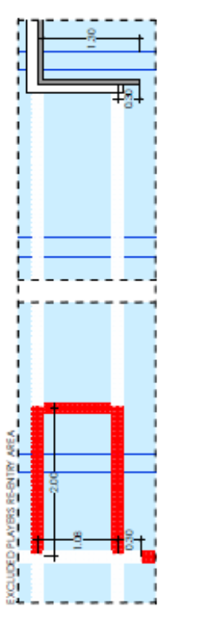

On one end Centered

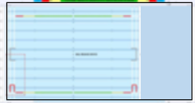 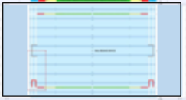

(b) red marks - 2 metres from goal lines (2M or 6.56 feet or 78.74 inches)

(c) yellow marks - 5 metres from goal lines (3M or 9.84 feet or 118.11 inches)  
The sides of the field of play from the goal line to the 2 metre line shall be marked in red; from the 2 metre line to the 5 metre line shall be marked in yellow and from the 5 metre line to the half distance line shall be marked in green.

**FR 9.1** Distinctive marks shall be provided on both sides of the field of play to denote the goal lines, lines 2.0 metres and 5.0 metres from that line and half the distance between the goal lines. These markings shall be clearly visible throughout the game. The white marker shall be measured from the anchor point and will be 0.3 metres to line up with the front of the edge of the goal line. This shall be consistent at both ends of the field. The 2 metre red marker shall be measured from the front end of the goal line extending into the field of play. This shall be consistent at both ends of the field of play. The yellow marker shall then extend 3 metres from the 2 metre marker into the field of play. This shall be consistent at both ends of the field of play. The middle section of the field of play will be green and should be 20 metres for the men’s game and 15 metres for the women’s game. There will be a white marker placed in the middle of the green area to denote the centre of the field. The exclusion zones shall be placed in the two corners on the opposite side of the pool to the official table. They shall be 2 metres in length and shall extend along the goal line.

**Water Polo Goal Tethers**

**FINA Rules: WP 1.7** A red mark shall be placed at each end of the field of play, 2 metres from the corner of the field of play on the side opposite to the official table, to denote the re-entry area.



**More about Water Polo tethers as not specifically outlined by FINA**

Water Polo Goal Tethers mark the end of field of play. They are used for securing Floating Goals to the Pool side walls.

Many end users prefer to use the Forereunner 4.75 Inch lanes as they have less chance of breaking if hit directly by a ball.

4 Tethers are used for each Goal, so 8 in total are used in a course.

On one side of the goal they are completely white. On the other side they are white and have a red re-entry square measuring 2M (6.56 feet or 78.7 inches) on one-side. This signifies the penalty re-entry area. This square also has a small red connecting section to make the square complete.

Connecting Section is Depth between Front and Rear Tether Anchors: 750mm or 29.5 inches.

To Determine Tether Length will need to know the Pool Width.

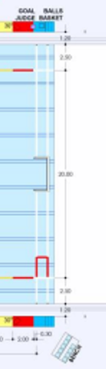

Example 20M width pool wanting to use FlipFloat Senior Folding Goal 750

The front tethers will be 8.26M or 27.1 feet each.

The rear tethers will be 8.19M or 26.9 feet each.

75’ Foot width pool

Front Tether = 900 inches – 136.89 inches = 763.11/2 = 381.56 inches or 31.79 feet or 31 ft and 9.5 in

Rear Tether = 900 inches - 142.40 inches = 757.60/2 = 378.80 inches or 31.57 feet or 32 ft and 7 in

25M width pool

Front Tether = 984.25 inches – 136.89 inches = 847.36/2 = 423.68 inches or 35.31 feet or 35 ft and 3.7 in

Rear Tether = 984.25 inches - 142.40 inches = 841.85/2 = 420.93 inches or 35.08 feet or 35 ft and 1 in

AW0674 FlipFloat Senior Folding Goal 750

1. Front Frame Anchor center to Anchor center: 3477mm, 3.48 m or 11.4 feet 136.89 Inch

2. Rear Anchor center to Anchor center: 3617mm, 3.62 m or 11.88 feet or 142.4 inches

Next page diagram

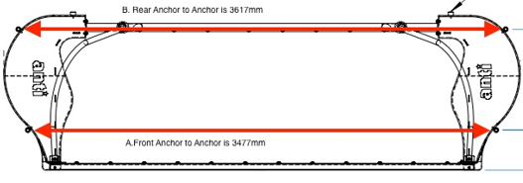

AW0550 Odyssey Anti Pro Goal 750:

1. Front Frame Anchor center to Anchor center: 3477mm, 3.48 m or 11.4 feet

2. Rear Anchor center to Anchor center: 3617mm, 3.62 m or 11.88 feet

AW0692 Junior Folding Goal/Flippa Goal:

1. Front Frame Anchor center to Anchor center: 2477mm, 2.477 m or 8.1 feet

2. Rear Anchor center to Anchor center: 2820mm, 2.820 m or 9.25 feet

**Installation:**

Lanes and Tethers connect to the Pool through either A or B.

A) Lane Anchor

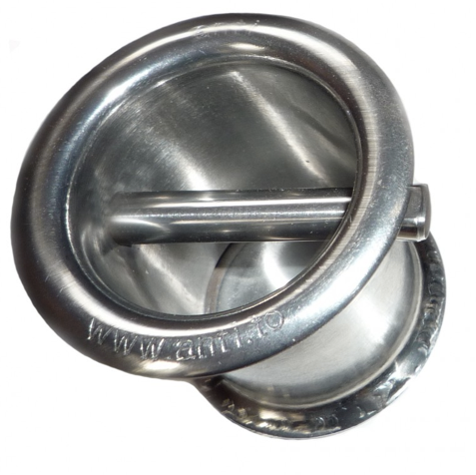

or

B) Overflow Lane Anchors – IF the Pool is Overflow type

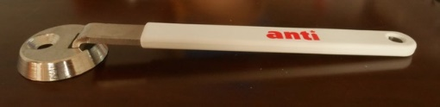

**FINA Water Polo**

**WP Water Polo Rules**

[https://www.fina.org/content/wp-1-field-play-equipment-0](https://linkprotect.cudasvc.com/url?a=https%3a%2f%2fwww.fina.org%2fcontent%2fwp-1-field-play-equipment-0&c=E,1,dtKWEwxpQVjLdYMzBsOqNhl_4cHQdyYsBAdbgegeyEKAAn_odB7GKblBkuEkGLEuaNjhtoH96IDRs2XpU-ueFcMd7VfTg6sPMJ7KfGgQGEIx7kU2_c3dFK8,&typo=0)

**FINA Rules: WP 1.1** The promoting organisation shall be responsible for the correct measurements and markings of the field of play and shall provide all required fixtures and equipment.

**WP 1.2** The layout and markings of the field of play for a game officiated by two referees shall be in accordance with this diagram:

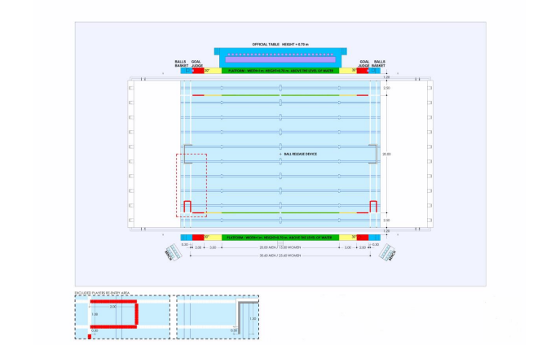

**WP 1.3** In a game officiated by one referee, the referee shall officiate on the same side as the official table, and the goal judges shall be situated on the opposite side.

**WP 1.4** The distance between the goal lines shall not be less than 20 metres and not more than 30 metres for games played by men. The distance between the goal lines shall not be less than 20 metres and not more than 25 metres for games played by women. The width of the field of play shall be not less than 10 metres and not more than 20 metres.

**WP 1.5** For FINA events, the dimensions of the field of play, water depth and temperature, and light intensity shall be as set forth in FR 7.2, FR 7.3, FR 7.4 and FR 8.3.

**WP 1.6** Distinctive marks shall be provided on both sides of the field of play to denote the following:

(a) white marks - goal line and half distance line (Most Goals are 1420mm or 55.9 inches deep, Also need to know how much space customer plans to put behind the Goal in their Course) to determine.   
(b) red marks - 2 metres from goal lines   
(c) yellow marks - 5 metres from goal lines   
The sides of the field of play from the goal line to the 2 metre line shall be marked in red; from the 2 metre line to the 5 metre line shall be marked in yellow and from the 5 metre line to the half distance line shall be marked in green.

**WP 1.7** A red mark shall be placed at each end of the field of play, 2 metres from the corner of the field of play on the side opposite to the official table, to denote the re-entry area.

**WP 1.8** Sufficient space shall be provided to enable the referees to have free movement from end to end of the field of play. Space shall also be provided at the goal lines for the goal judges.

**WP 1.9** The secretary shall be provided with separate white, blue, red and yellow flags, each measuring 0.35 metres x 0.20 metres.

**FR 7 Facilities Rules**

<https://www.fina.org/content/fr-7-pools-water-polo>

**FR 7.1 General requirements:**Water Polo Dimensions and Equipment as detailed in Field of Play for Olympic Games and World Championships. See Water Polo Diagram, Annex 4

**FR 7.2 Field of Play.** The distance between the respective goal lines shall be 30.0 metres for games played by men and 25.0 metres for games played by women. The anchor point at the edge of the field of play shall be placed 30cm behind the front of the goal line. The width of the  
field of play shall be 20.0 metres. The depth of the water shall be consistently not less than 1.8 metres and preferred 2.0m. The overall field of play including the goal area will be 30m x 25m for men and 25m x 20m for women.

**FR 7.3** The water temperature shall not be less than 26° plus 1° minus 1° Centigrade.

**FR 7.4** The light intensity shall not be less than 600 lux.

**FR 7.5** Exception from FR 7.2 may be allowed on the discretion of the federation controlling the match.

**FR 7.6** The game secretariat shall be placed at a table behind the referees and at the same height

**FR 8 Water Polo Pools for Olympic Games and World Championships**

<https://www.fina.org/content/fr-8-water-polo-pools-olympic-games-and-world-championships>

**FR 9 Equipment for Water Polo Pools**

<http://www.fina.org/content/fr-9-equipment-water-polo-pools>

**FR 9.1** Distinctive marks shall be provided on both sides of the field of play to denote the goal lines, lines 2.0 metres and 5.0 metres from that line and half the distance between the goal lines. These markings shall be clearly visible throughout the game. The white marker shall be measured from the anchor point and will be 0.3 metres to line up with the front of the edge of the goal line. This shall be consistent at both ends of the field. The 2 metre red marker shall be measured from the front end of the goal line extending into the field of play. This shall be consistent at both ends of the field of play. The yellow marker shall then extend 3 metres from the 2 metre marker into the field of play. This shall be consistent at both ends of the field of play. The middle section of the field of play will be green and should be 20 metres for the men’s game and 15 metres for the women’s game. There will be a white marker placed in the middle of the green area to denote the centre of the field. The exclusion zones shall be placed in the two corners on the opposite side of the pool to the official table. They shall be 2 metres in length and shall extend along the goal line.

**FR 9.2** Platforms must be provided on both sides of the field of play, which shall be 1 metre in width and 70 cm in height above the water level. These platforms enable the referees to have free way from end to end of the4 field of play. Sufficient space shall also be provided at the goal lines for the Goal Judges. The platforms must be colour coded to meet the specification as shown in the diagram of the field of play Annex 4.

**FR 9.3**Goals: The goal posts and crossbar must be of wood, metal or synthetic (plastic) with rectangular sections of 0.075 metre, square with the goal line and painted white. The goal posts must be fixed, rigid and perpendicular at each end of the playing space, equal distances from the sides and at least 0.3 metre in front of the ends of the field of play or of any obstruction. Any standing or resting place for the goalkeeper other than the floor of the pool is not permitted.

**FR 9.4** The inner sides of the goal posts must be 3.0 metres apart. The underside of the cross bar must be 0.9 metres above the water surface.

**FR 9.5** The underside of the crossbar must be 0.9 metre above the water surface when the water is 1.5 metres or more in depth, and 2.4 metres above the bottom of the pool when the depth of the water is less than 1.5 metres.

**FR 9.6** Limp nets must be attached to the goal fixtures to enclose the entire pool space securely fastened to the goal posts and crossbar, allowing not less than 0.3m of clear space behind the goal line everywhere within the goal area.

